# Setting up LabVIEW19

## Download

1. Install LabVIEW 2019 with myrio toolkit: SPECIFICALLY **- LabVIEW 2019 myRIO Software Bundle (or newer version)**

or

install **ni-myrio-software-bundle-x86_7.0_suite_online_repack2.exe**

1. Install VI Package Manager from <https://vipm.jki.net/>
2. Install from within VI Package Manager all the OpenG packages for LabVIEW 2019

## The Installation:

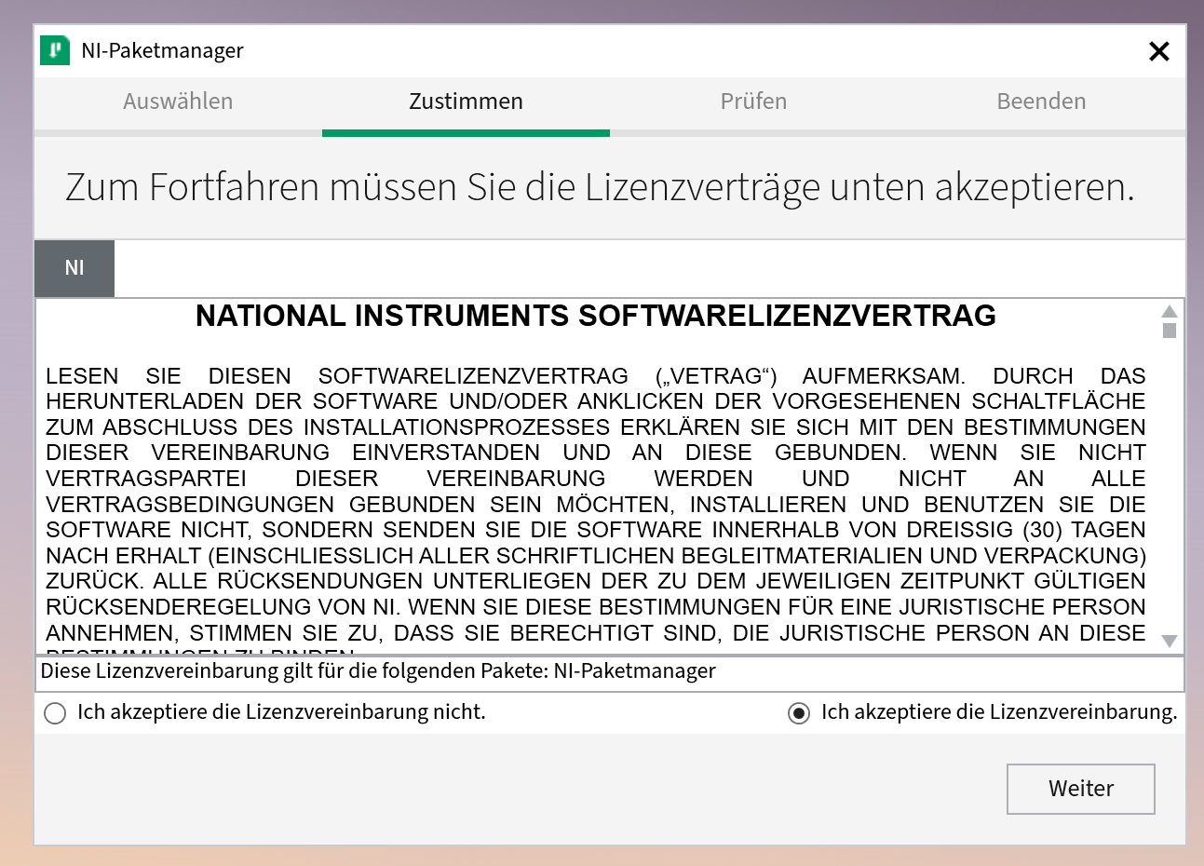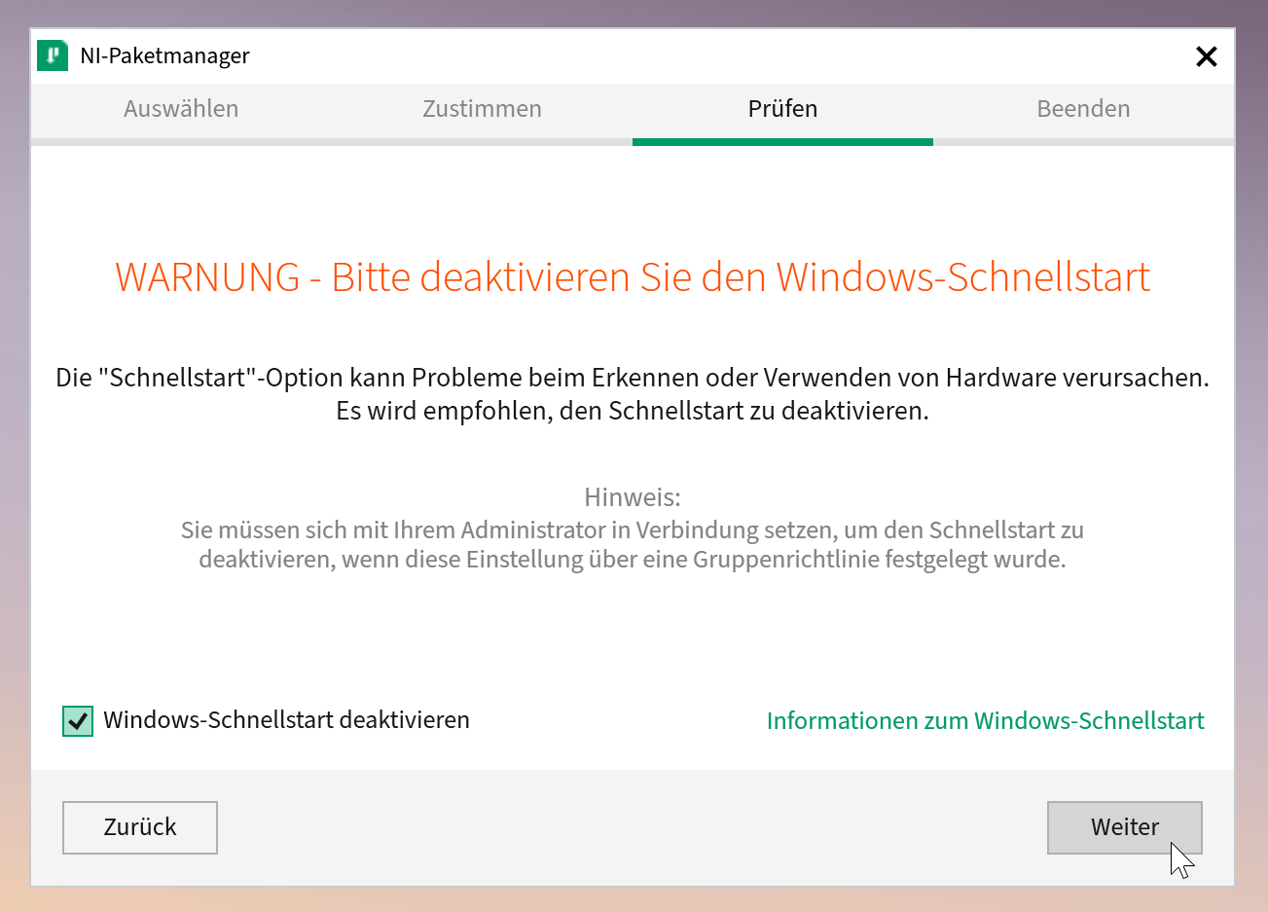

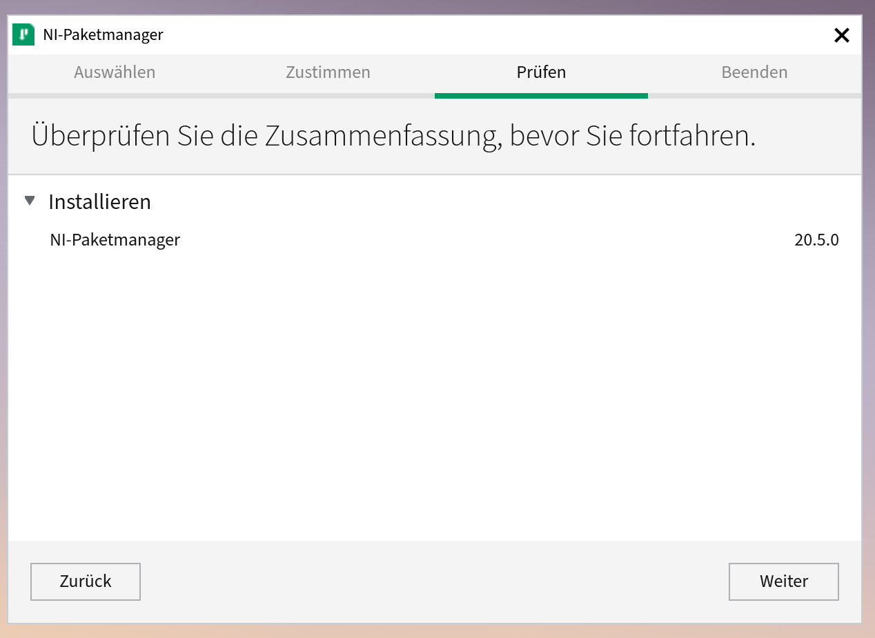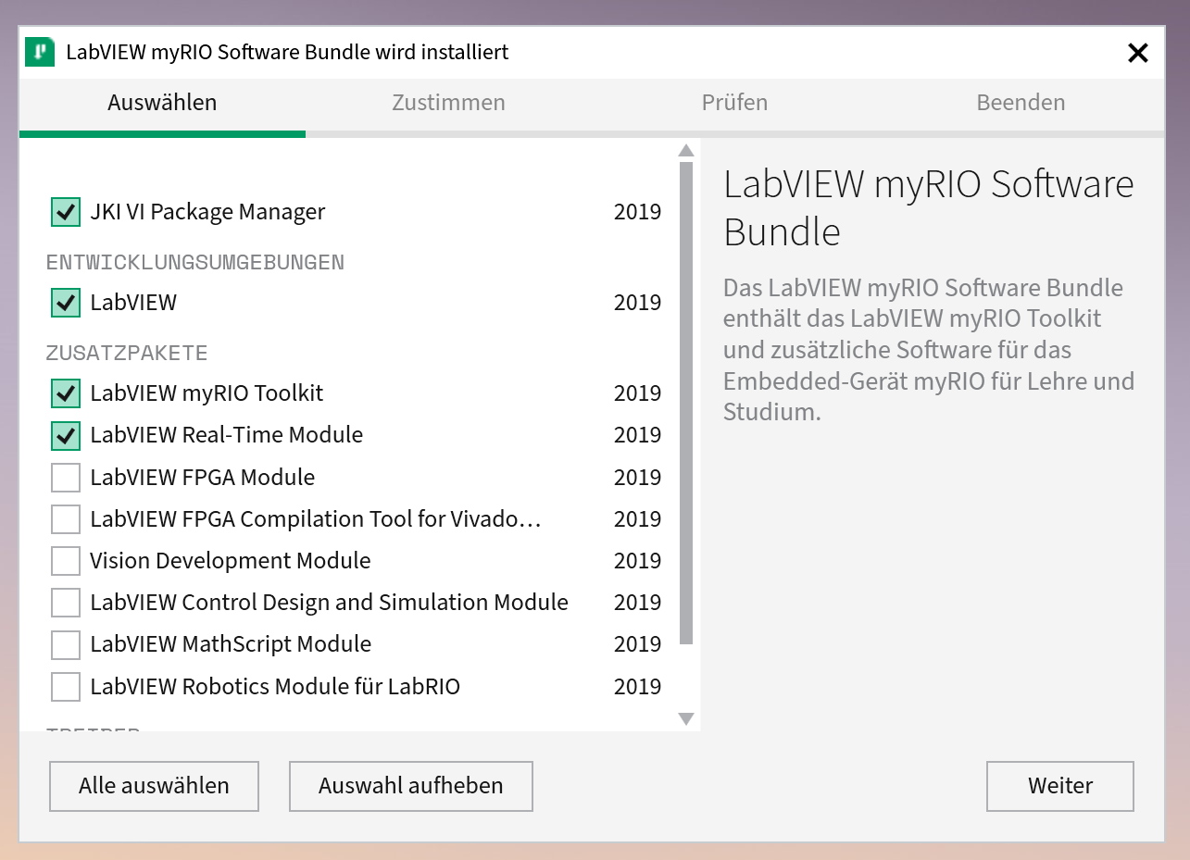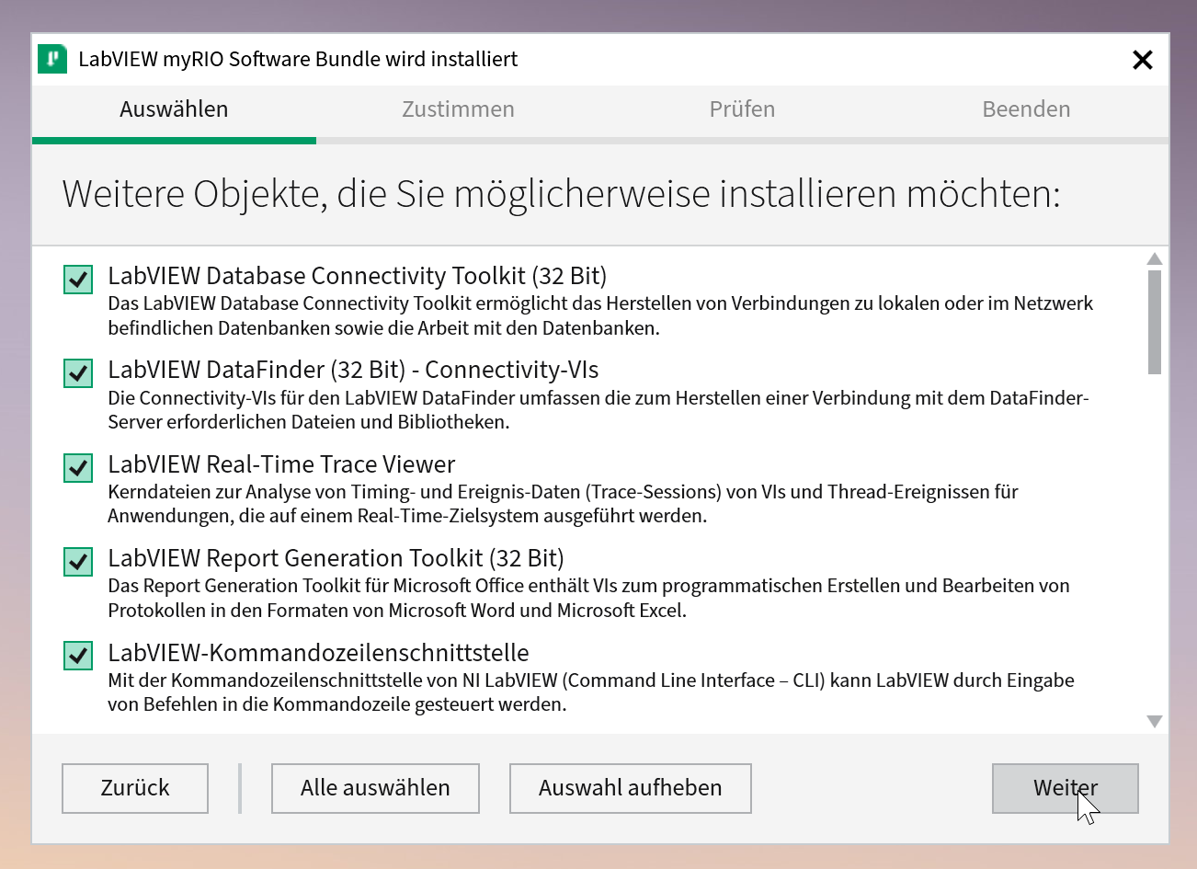

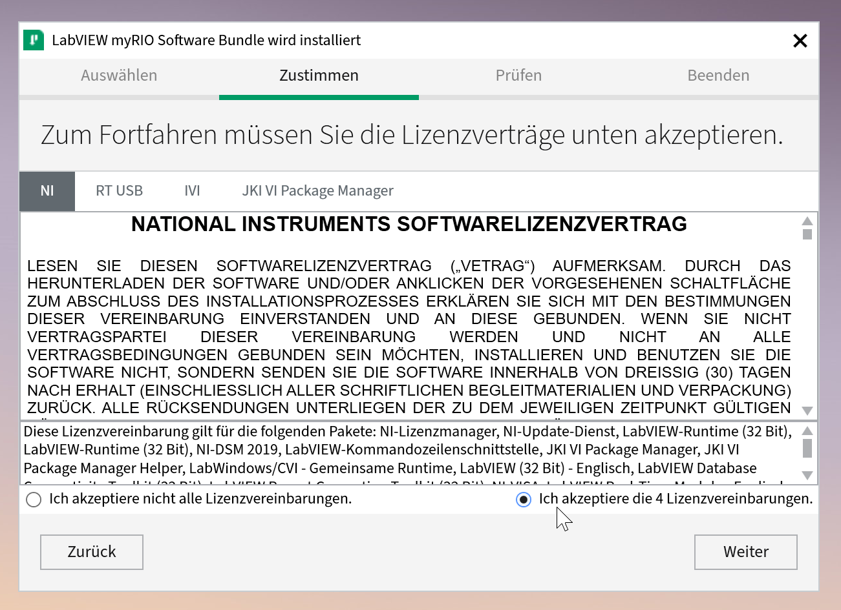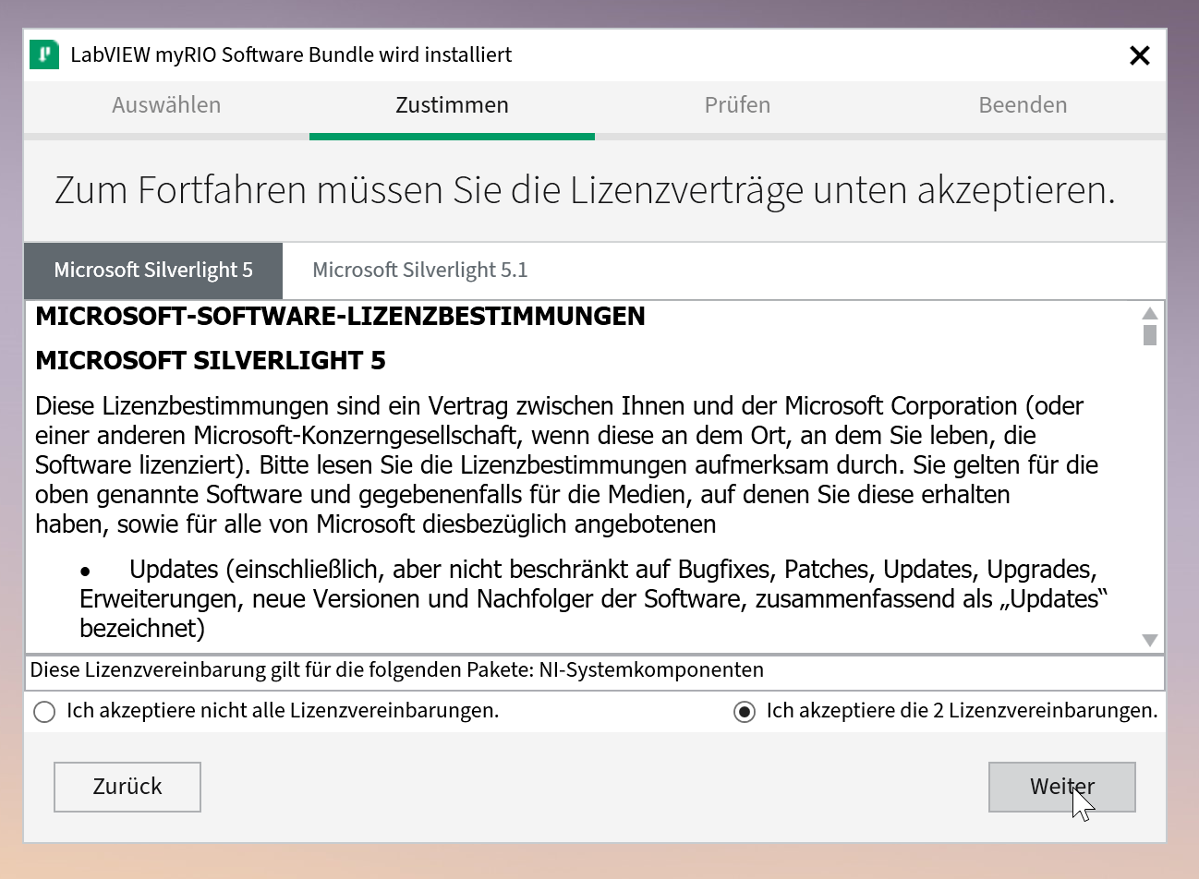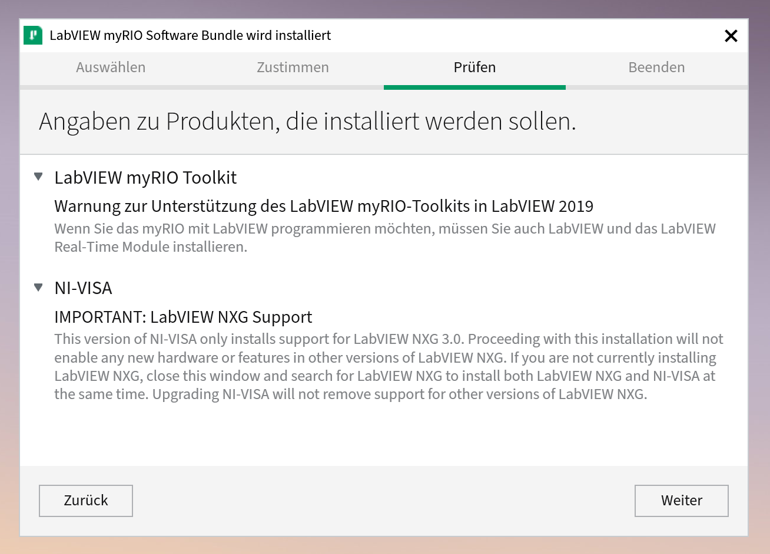

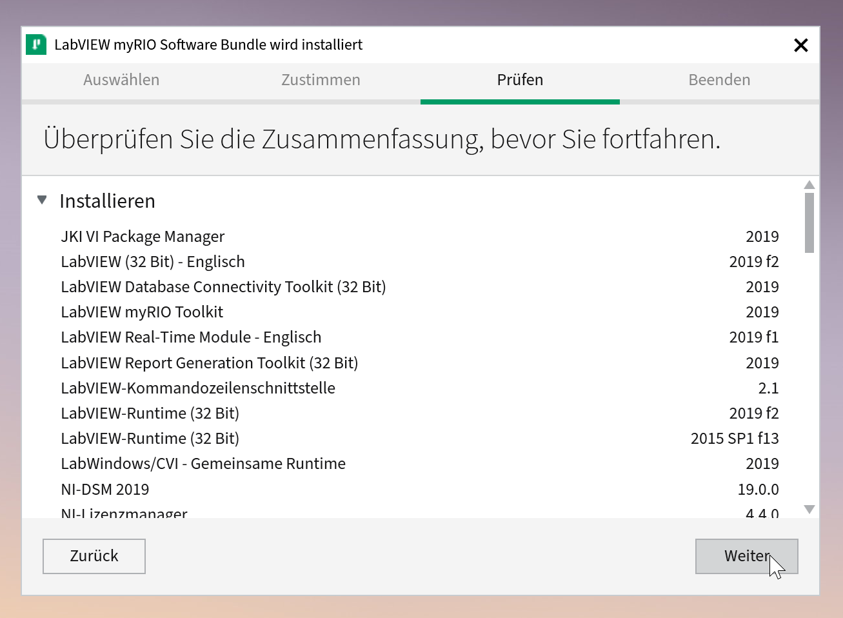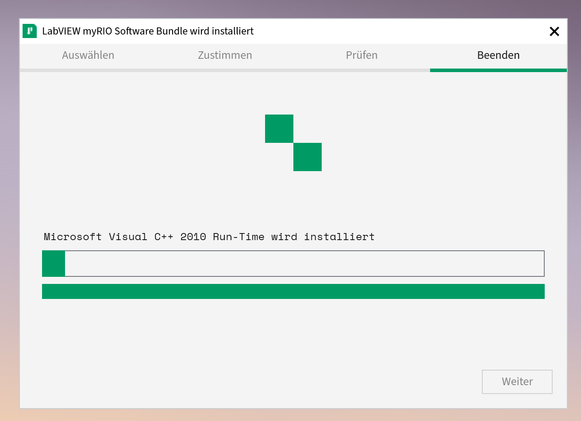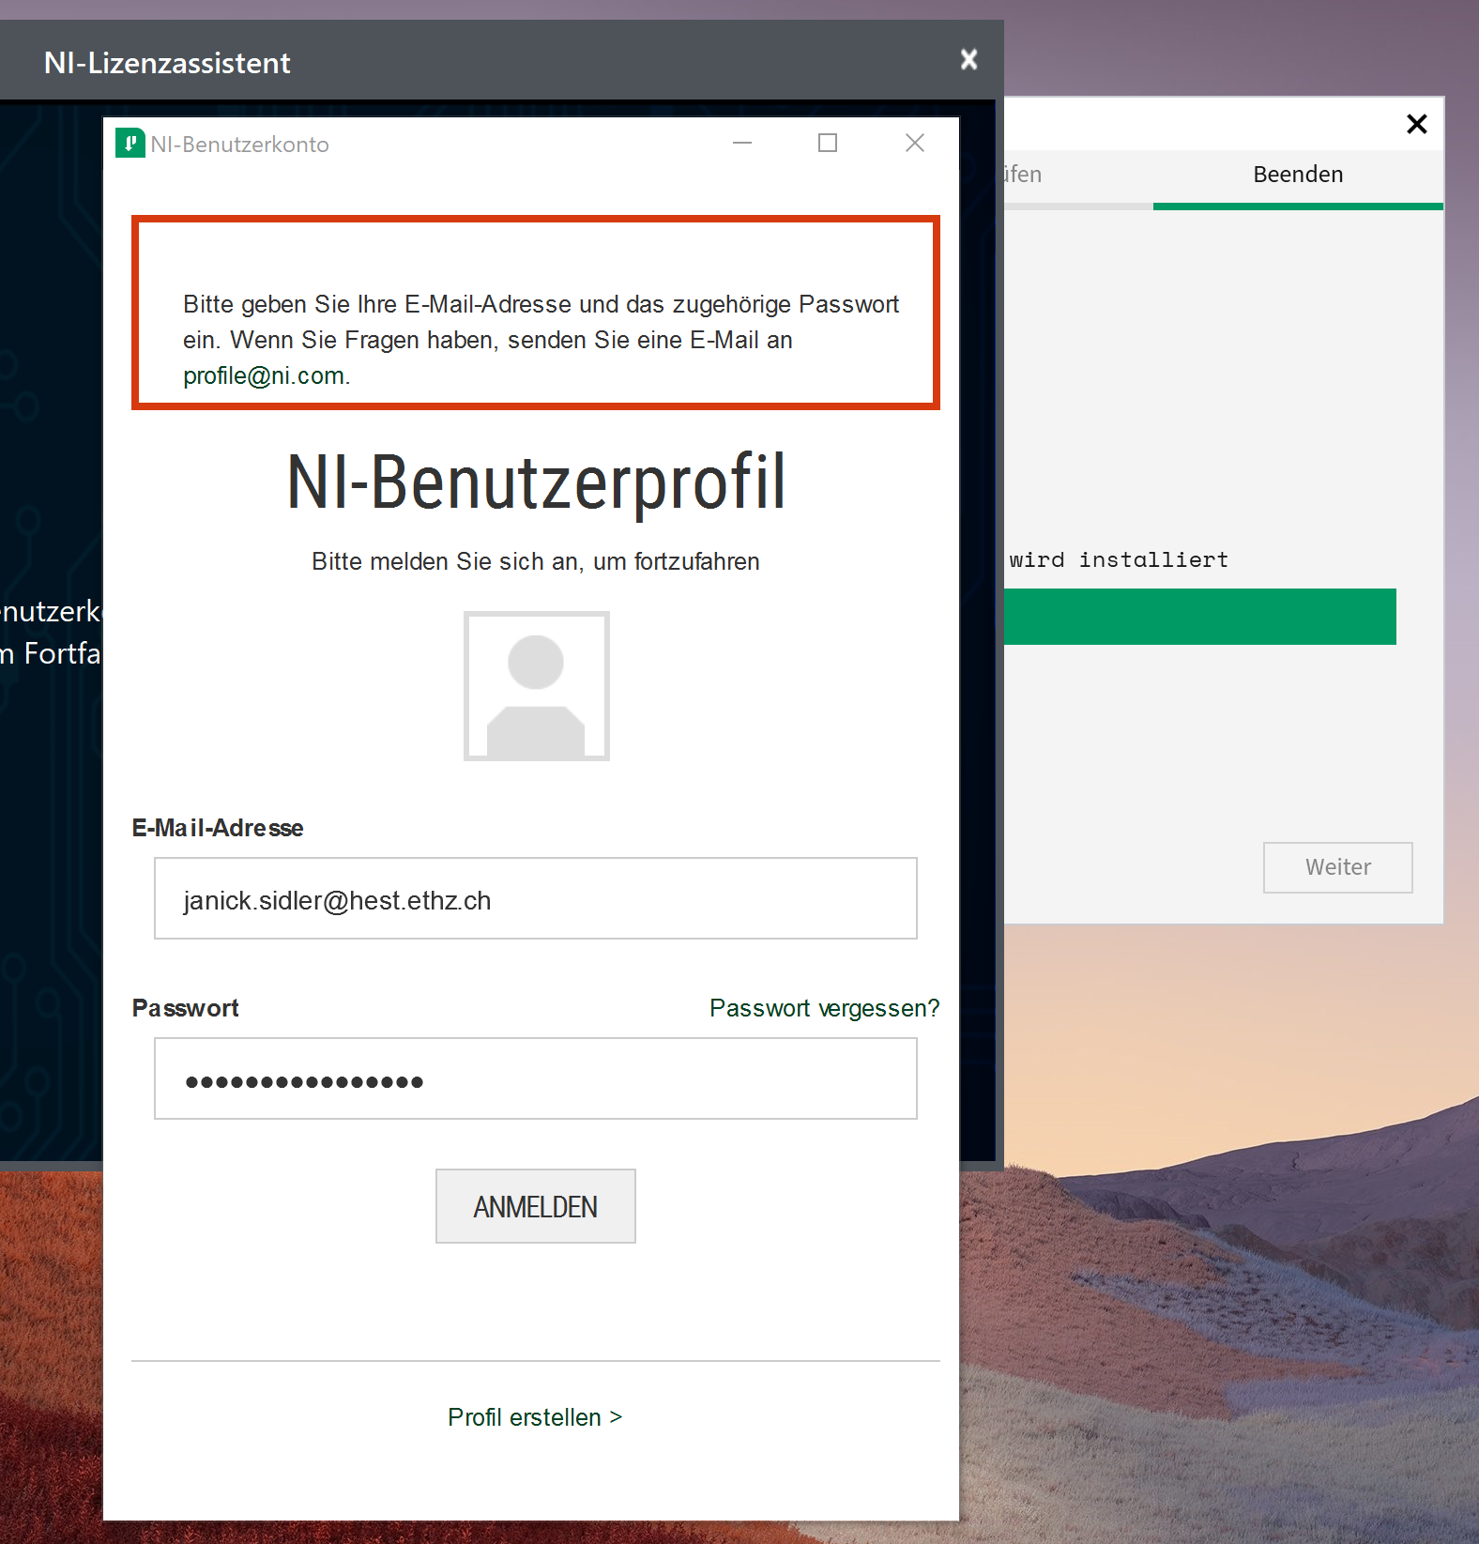

Note: when performing the installation on the tablet, make sure to use the NI user profile of the supervisor, as it gets displayed when opening Labview.

